# CS 255 System Design Document Template

## UML Diagrams

### UML Use Case Diagram

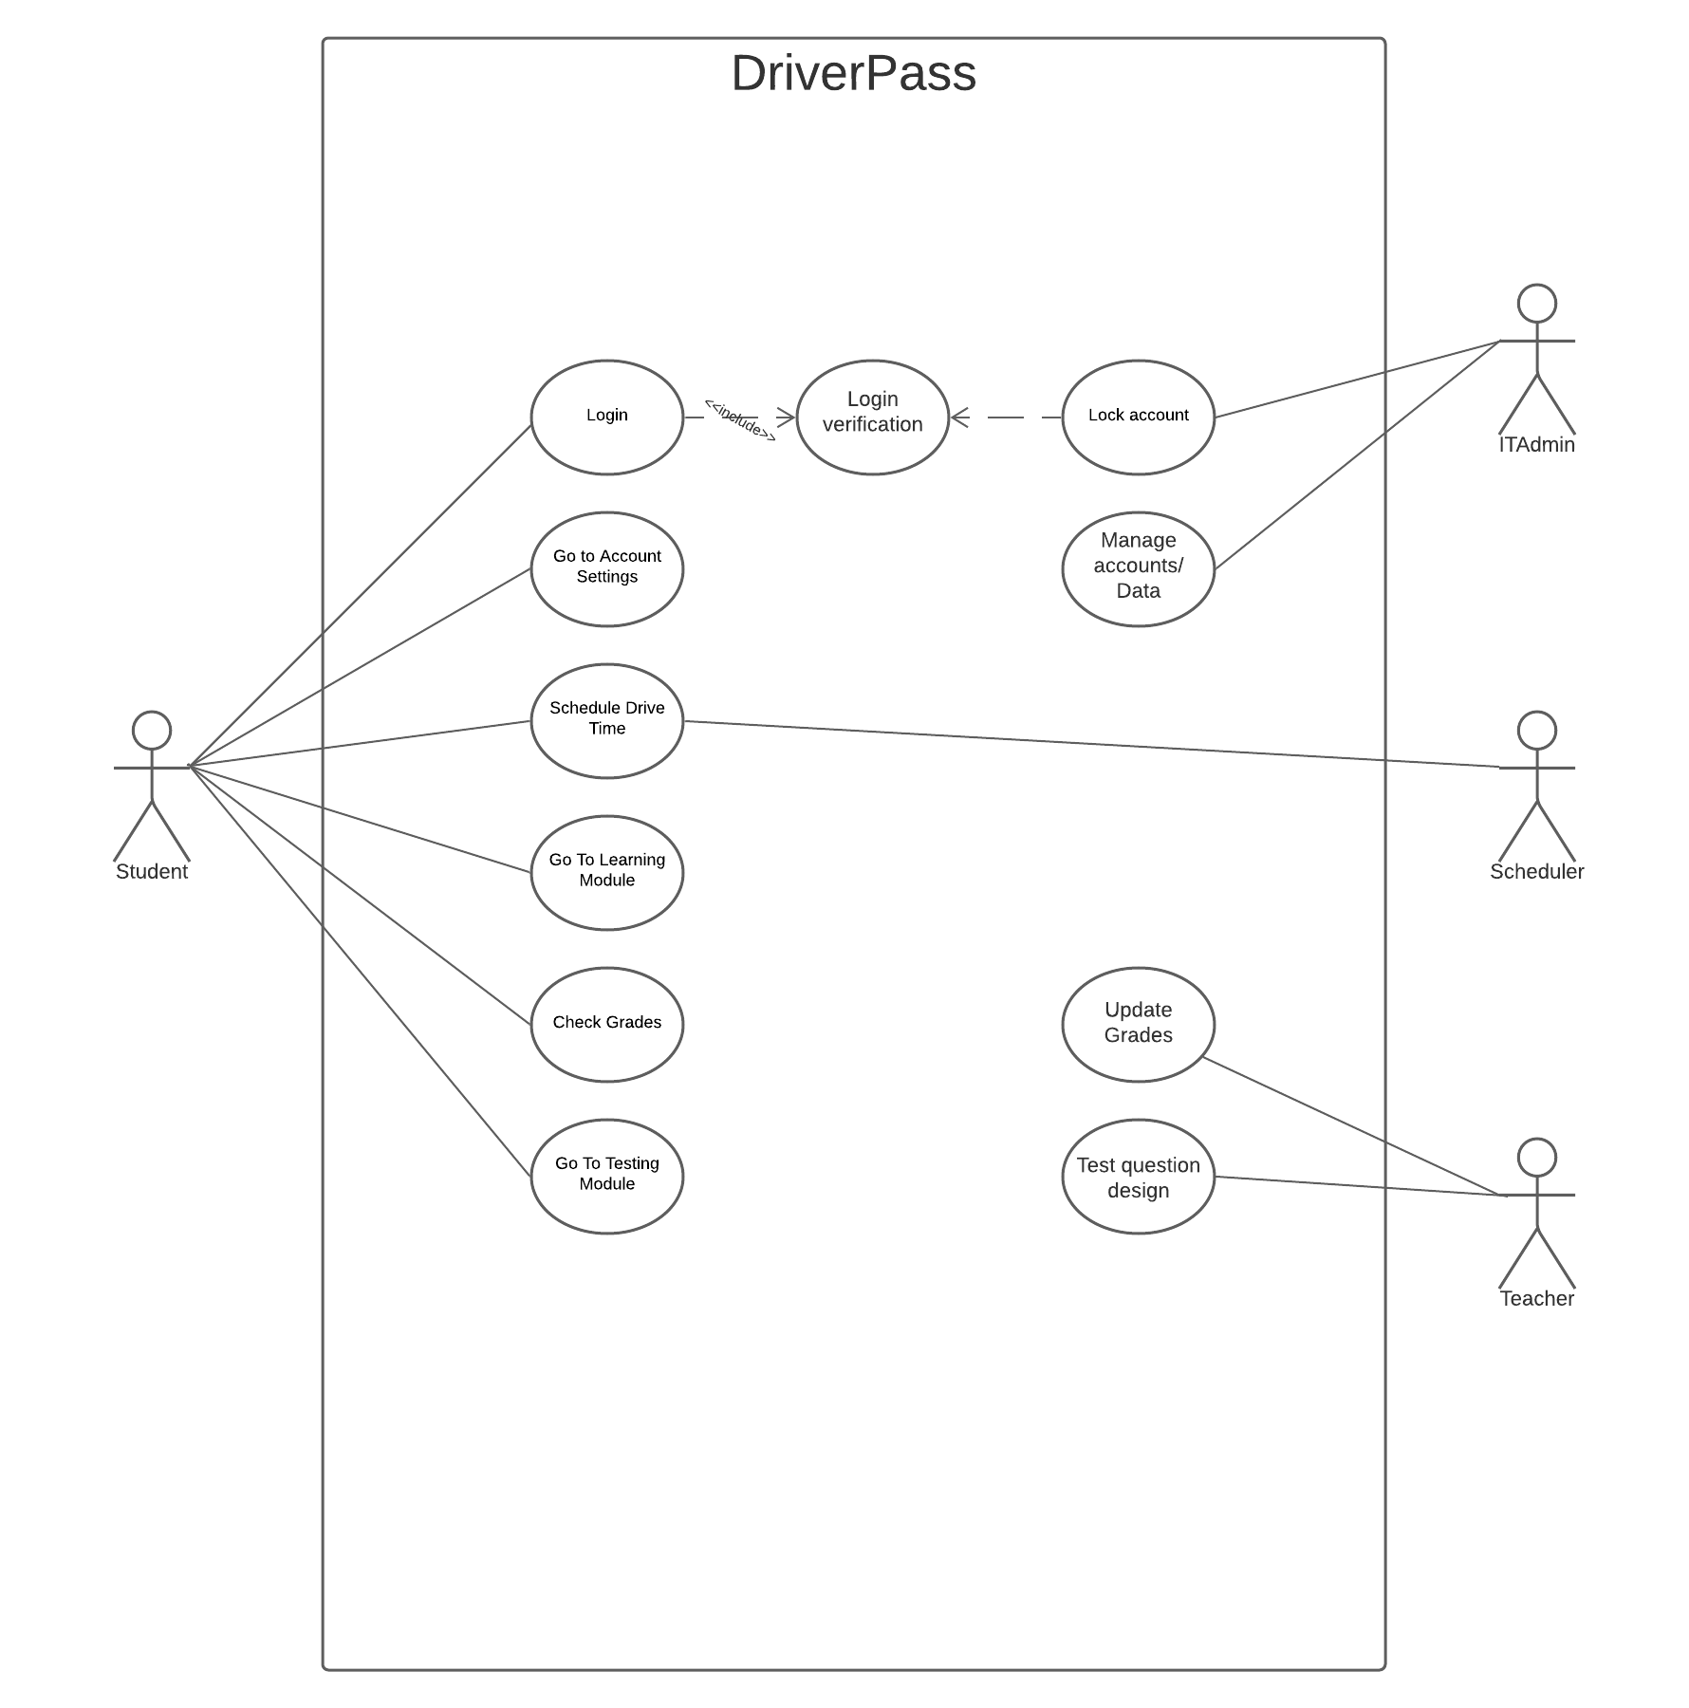

### UML Activity Diagrams

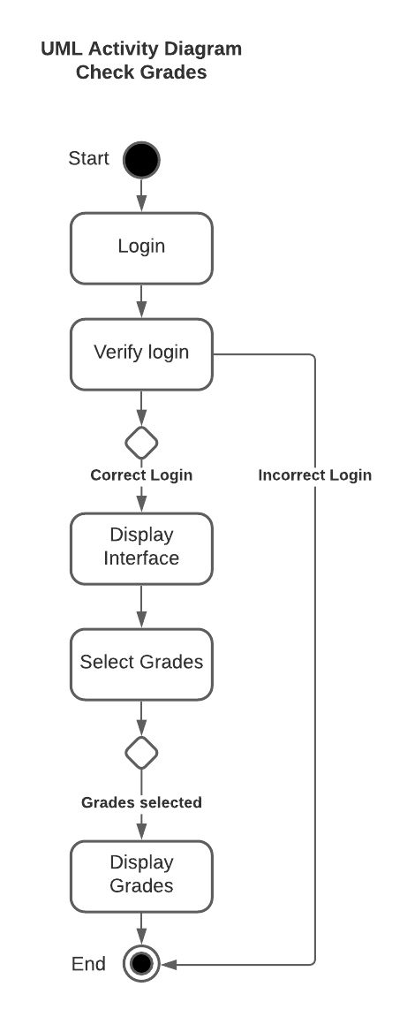

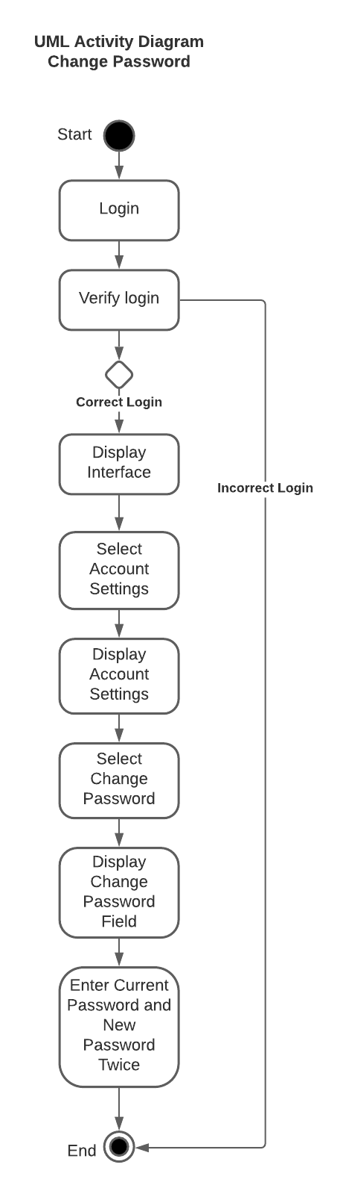

### UML Sequence Diagram

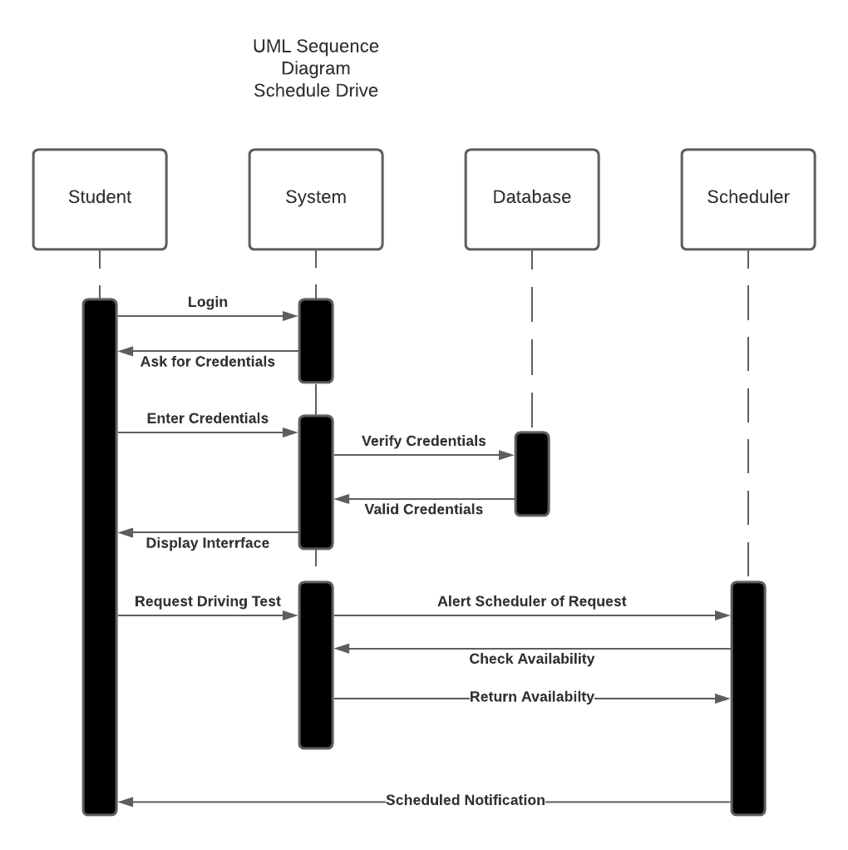

### UML Class Diagram

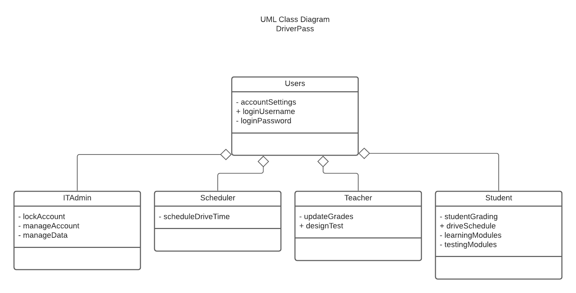

## Technical Requirements

This system will require a database for storing all user information

The system will run on a Windows server

The system will meet all Windows recommended hardware requirements for web-based application development.

The system will need integration with DMV website